|  |  |
| --- | --- |
|  | **2013** |
|  | Devry University  Heather Waters  Luke Cossel  Chris Favela  Joshua Barnett  Chris Martinez |
|  |  |

|  |
| --- |
| **[Ghost hunter X]** |
|  |

# Title

Ghost Hunter X

# Genre

Shooter

# Target Platform

PC / XBLA / PSN

# High Concept

Ghost Hunter X is a 3d shooter in which you have to explore a haunted house and kill ghosts and gain access to other parts of the mansion through acquiring keys from goals and puzzles met.

# Audio

## Music

The music will be made from scratch and will usually be upbeat fast or casual walking around music for the easier levels.

|  |  |  |
| --- | --- | --- |
| **Level / Menu** | **Asset Type** | **Asset description** |
| Title Menu | Midi | Slow Heavy Rock |
| Options | Midi | Slow Department Store Music |
| Mansion exploring | Midi | Walking Around Music(more creepier than usual |

## Sound Clips

Sound clips will be comprised of effects such as car crashes, explosions, and gunfire. Other effects include dings for picking up items, an annoying beeping sound to indicate you are low on health, and honks for enemy cars.

|  |  |  |
| --- | --- | --- |
| **Asset Name** | **Asset Type** | **Asset description** |
| Attack | Wav | Player Melee / Enemy Melee |
| Gun Shot | Wav | Player Shot / Enemy Shot |
| Evil Aura | Wav | Plays When Near Goth Kids |
| Screams | Wav | Enemy / Player Dies |
| Pip Noise | Wav | Menu Scrolling |
| Chime | Wav | Menu Select |
| WinSound | Wav | Player Wins |
| LoseSound | Wav | Player Loses |
| Weapon Reload | Wav | Player Reloads weaopon |
| Goal Item Pick Up | Wav | Award Noise For Goal Item |

# Controls

The controls will be quite simple and forward.

## Keyboard Setup

For PC, “W” or “Up Arrow” to go up, “S” or “Down” for down, “A” or “Left Arrow” for Left, “D” or “Right Arrow” for right. The Interact Key will be “Left Shift” or “Right Shift” and the Action/Attack Key is “Space”.

GamePad Setup

For XBLA and PSN, “Left Stick Up” or “D-Pad Up” to go up, “Left Stick Down” or “D-Pad Down” for down, “Left Stick Left” or “D-Pad Left” for Left, “Left Stick Right” or “D-Pad Right” for right. The Interact Key will be “X(Xbox)” or “Square(PS)” and the Action/Attack Key is “A(Xbox)” or “X(PS)”.

# Game Modes

Story Mode:

* + Player collects keys to unlock different parts of the mansion to rid the mansion of all the ghosts. The player cannot move farther in the mansion until the key has been acquired. Each room is locked with a door which a key is needed to open the door to the next room.

Win-Condition:

* + Defeats all ghosts in each area of the mansion to receive a door key to open the locked door to the room and continue this until the mansion ghost free.

Loss-Condition:

* + Player losses all lives by being killed after losing health from attacks from the various ghosts throughout the mansion.

**AI System:**

The AI will vary depending on the enemies and will be explained in detail along with the enemies.

**Enemies:**

|  |  |  |
| --- | --- | --- |
| **Enemy Name** | **AI Type** | **Description** |
| Yellow Ghosts | Wandering/seek/fleeing/attacking | Flys Aimlessly Around Mansion/ attacks player in assigned area |
| Blue Ghosts | Wandering/seek/fleeing/attacking | Flys Aimlessly Around Mansion/ attacks player in assigned area |
| Red Ghosts | Wandering/seek/fleeing/attacking | Flys Aimlessly Around Mansion assigned area |
| Green Ghosts | Wandering/seek/fleeing/attacking | Flys Aimlessly Around Mansion assigned area |
| Boss Ghost | Wandering/seek/fleeing/attacking | Attacks player and wanders |

# Game User Interface

The user interface will be straightforward and simple enough to understand by the picture below.

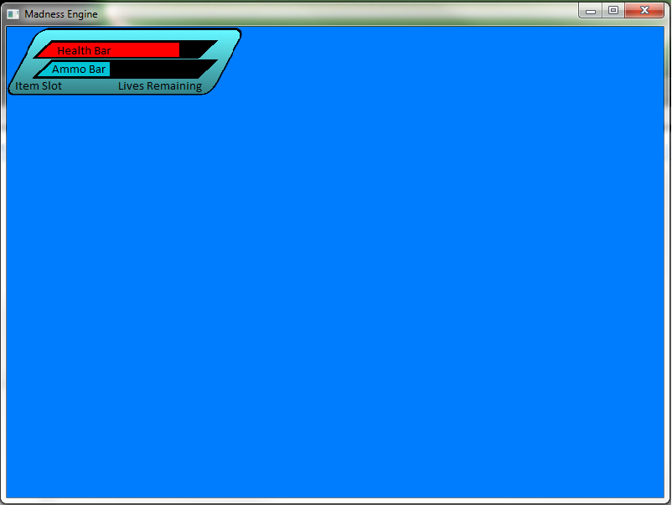

|  |  |
| --- | --- |
| **Name** | **Description** |
| **Player Health** | This shows player health. |
| **Weapon Ammo** | This will show how much ammo the player currently has |
| **Item Menu** | This will show what items player has at current time |
| **Lives Remaining** | This will display the lives remaining for the player. |

Game Menu Screens

The menu have a Main Menu, Pause Menu, and Options Menu.

* + Main Menu
    - Play Game → Game → Pause Menu → Main Menu / Option Menu
    - Options → Options Menu → Main Menu
    - Exit Game → Quits Game
  + Options
    - Full Screen → ON/OFF
    - vSync → ON/OFF
    - Music → ON/OFF
    - Sounds → ON/OFF
    - Return → Main Menu
  + Pause
    - Resume → Game
    - Options → Options Menu
    - Quit → MainMenu